Part 1 & Part 2

1a A student builds a circuit. The circuit is shown in Figure 1.
Label the components shown in Figure 1. (3)
Figure 1
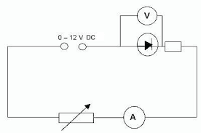
- Voltmeter
- Power Supply
- Diode
- Resistor
- Variable Resistor
- Ammeter

(1 mark / two correct answers)

1b A resistor adds resistance to a circuit.
Describe what the effect of adding resistance would have on the current flowing in the circuit. (2)
- Increasing the resistance decreases the current. (1)
- Current halves if resistance doubles / inversely proportional. (1)

1c In another electrical circuit a current of 1.2 A flows for 17 seconds.
Work out the charge flow in the circuit. Give the units of charge. (3)
- Q = I x t (1)
- Q = 1.2 x 17
- Q = 20.4 (1)
- C (1)

2 A student sets up the circuit shown in Figure 2 to measure the resistance of a resistor.
Figure 2

0.4 mA

3.6 V

2a(i) Work out the resistance of the resistor in the circuit. (3)
- V = I x R (1)
- R = V / I (1)
- R = 3.6 / 0.4
- R = 9 Ω (1)
2a(ii) The student adds a variable resistor into the circuit.
The variable resistor is used to get range of values for the potential difference and the current in
the circuit.
Draw a graph to show how the potential difference and the current across the resistor are linked.
Label this line A. (1)

Potential Difference / V
A
B
Current / A

2a(iii) The resistor is replaced with a different resistor that has a lower value of resistance.
On the axes given for 2a(ii), draw a line to show how the current and the potential difference are now linked for this new resistor. Label this new resistor line B. (1)

2a(iv) A resistor is an ohmic conductor.
Explain what is meant by an ohmic conductor. (1)
- An ohmic conductor is one in which the current through the conductor is proportional to the potential difference across its ends. (1)
2a(v) State the conditions required for the resistor to obey ohm's law. (1)
- For ohm's law to apply the conductor must be at a constant temperature. (1)
2b The resistor in Figure 2 is replaced with a filament lamp.
The graph shown in Figure 3 shows how the current and potential difference are linked.
Figure 3
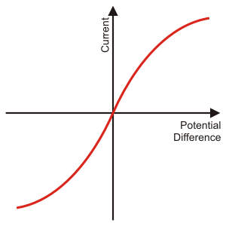

Explain the shape of the current - potential difference graph for a filament lamp. (6)
- As the current increases, the filament gets hotter (1)
- Making the atoms inside the filament vibrate faster (1)
- Increasing the number of collisions, the electrons undergo (1)
- Therefore, increasing the resistance of the filament lamp (1)
- The gradient of an I - V graph shows 1 / resistance (1)
- So, the steeper the line, the lower the resistance. (1)

3a (i) A teacher wants to demonstrate the properties of series and parallel circuits.
The teacher sets up a circuit with three identical filament lamps connected in series with a
battery and an open switch.
Draw the circuit that the teacher would set up. (3)
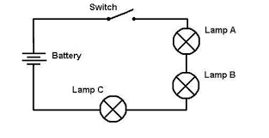
Correct circuit symbols (1)
All components in series (1)
Switch open (1)

3a(ii) Each filament lamp has a resistance of 14 Ω.
Work out the total resistance of the three filament lamps in series. (2)
- R_{T} = R₁ + R₂ + R₃ (1)
- R_{T} = 14 + 14 + 14
- R_{T} = 42 Ω (1)
3a(iii) The teacher now adds a fourth filament lamp in series with the other three.
Describe the effect that adding this extra filament lamp will have on the circuit. (4)
- Adding an extra filament lamp will increase the resistance (1)
- To 56 Ω (1)
- Decreasing the current in the circuit (1)
- And making all filament lamps dimmer. (1)

3b The same four filament lamps are now placed into a parallel circuit.
Describe how adding filament lamps in parallel affects the brightness of the filament lamps
compared to the brightness of a single filament lamp. (1)

- All bulbs will be as bright as a single bulb in series. (1)

4a Six identical filament lamps are placed in a parallel circuit.
The current through each filament lamp is 3 A.

Work out the current drawn from the power supply. (2)
- Current through the main branch of a parallel circuit equals the sum of the current in all
the branches leading off. (1)

- So, the current in main branch is 18 A. (1)

4b Two resistors, R₁ and R₂, are placed in parallel.
R₁ has a resistance of 120 Ω and R₂ has a resistance of 80 Ω.
The total resistance of the two resistors is less than 80 Ω.

Explain why adding resistors in parallel decreases the total resistance. (4)
- Adding resistors in parallel decreases the overall resistance (1)
- As there are more pathways for the current to travel through (1)
- So, the current flow increases (1)
- And the resistance decreases. (1)

5 Home electrical wiring uses three core electrical cables.
5a Match the name, colour and function of each wire. (3)

Name of Wire |  | Colour of Wire |  | Function of Wire
Earth |  | Blue |  | Safety Wire
Live |  | Brown |  | To supply high voltage
Neutral |  | Yellow / Green |  | To complete the circuit

5b(i) State the potential difference found in each wire when it is operating under normal conditions. (3)

Live: 230 V (1)
Earth: 0 V (1)
Neutral: 0 V (1)
5b(ii) State the frequency of the mains electricity supply. (1)
- 50 Hz (1)
5c The live wire can be dangerous even if a switch on the mains circuit is open.
Explain why the live wire can still be dangerous. (3)

- Touching the live wire could complete the circuit (from the live wire through you to
ground) (1)
- If there is a complete circuit then current can flow (1)
- Causing a major electric shock. (1)
5d(i) Draw the output trace that you would get from a direct potential difference (dc) supply. (1)

Potential Difference
Time

(1)

5d(ii) Draw the output trace that you would get from an alternating potential difference (ac) supply. (1)

Time
Potential Difference

(1)

6a A kettle has a power rating of 1.2 kW.
The kettle uses mains electricity at 230 V.

Work out the current flowing through the kettle. (4)
- P = V x I (1)
- Conversion: 1.2 kW = 1200 W (1)
- I = P / V (1)
- I = 1200 / 230
- I = 5.2 A (1)
6b Describe the useful energy transfer that takes place in a kettle. (1)
- Electrical energy to heat / thermal energy. (1)
6c Another kettle has a power rating of 1.5 kW.
This kettle takes 90 seconds to boil the water.

Work out the energy transferred by the kettle in the 90 seconds.
Give the correct unit with your answer. (4)
- E = P x t (1)
- Conversion: 1.5 kW = 1500 W (1)
- E = 1500 x 90
- E = 135,000 (1)
- J (1)
7a An electric motor is used to raise a lift.
The electric motor is connected to mains electricity at 230 V and has a power rating of 5 kW.
It takes the electric motor 35 seconds to raise the lift 20 meters.

Work out the charge flow in the electric motor. (4)
- E = P x t (1)
- E = 5000 x 35
- E = 175,000 J (1)
- E = Q x V
- Q = E / V (1)
- Q = 175 000 / 230
- Q = 761 C (1)

7b(i) Describe the useful energy changes that take place in an electric motor. (1)
- Electrical energy to kinetic energy. (1)

7b(ii) Describe how energy is wasted in an electric motor. (2)
- Energy wasted as heat / thermal (1)
- Warming up the surroundings (1)
8a An overhead powerline is used to transmit electricity from power stations to our homes.
A powerline carries a current of 350 A and has a power loss of 4 MW.

Work out the resistance of the powerline. (4)
- P = I² x R (1)
- Conversion: 4 MW = 4,000,000 W (1)
- R = P / I² (1)
- R = 4 000 000 / (350)²
- R = 32.7 Ω (1)
8b Explain why the current through the powerline is made as low as possible in The National
Grid. (4)
- Increasing the potential difference decreases the current
- As P = V x I and the power does not change.
- The greater the current the more the powerlines heat up
- Wasting energy to the surroundings as thermal / heat energy
- Using transformers makes the transmission more efficient.
(any 4 valid points)
8c Describe how the current is reduced before transmitting the electricity through the powerlines. (2)
- The current is reduced by using a step-up transformer (1)
- Which increases the potential difference and decreases the current. (1)

Part 3
1 This question is about static electricity.
1a State the two types of static charge. (1)
- Positive and negative (1)

1b(i) A plastic rod has been given a positive charge by rubbing the plastic rod on a cloth.
Explain how the plastic rod has been given a positive charge in terms of movement of particles (2)
- Electrons (1)
- Removed from the rod (1)

1b(ii) The charged plastic rod is placed above some fine dust particles.
Describe the effect that the charged rod will have on the dust. (1)
- Dust particles will attract to the charged rod. (1)

1c Xavi walks across a carpet.
Once Xavi has crossed the carpet he touches an earthed metal radiator and gets an electric shock.
Explain why Xavi gets an electric shock when he touched the earthed radiator. (3)
- Walking across the carpet builds up a charge (1)
- Touching an earthed object will allow electrons to move through you from / to
ground (1)
- Giving you an electric shock. (1)

2 Static is used in the spray painting of car doors.
Figure 1 shows a car door being spray painted using static.

Figure 1
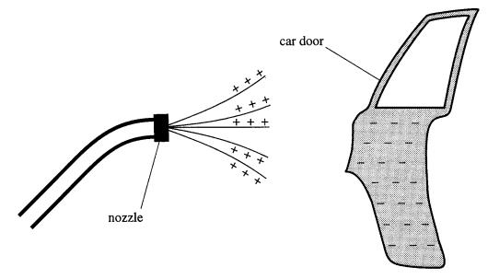
2a(i) Explain why electrostatic spray painting produces a fine spray. (3)
- All the paint droplets have a positive charge (1)
- Like charges repel (1)
- Paint particles disperse. (1)
2a(ii) Explain why the car door is given a negative charge. (3)
- Door is negative to attract the oppositely charged paint droplets
- Allowing them to get to hard to reach areas
- And cover front and back at the same time
- To produce an even layer of paint over the entire surface
(any 3 valid points)
2a(iii) Suggest an advantage of electrostatic spray painting over the use of tins of spray paint. (1)
- Quicker / even coat / better finish / gets too hard to reach areas (1)
2b(i) A droplet of paint has been given a positive charge.
Draw the electric field for this paint droplet. (1)
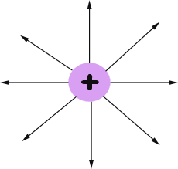

2b(ii) Describe what would happen if another positively charged particle was placed into this electric
field. (2)

- The positively charged particles would move away from each other (1)
- As there would be a force acting on the charges. (1)

2c A spark is formed when a charged object is earthed.
Explain why a spark forms. (3)
- When the strength of the electric field exceeds the dielectric field strength
- The dielectric breaks down, giving an increased number of free electrons
- Which are able to conduct
- Causing a spark.
(3 valid points)

